Lab : Creating a database

**1 Database modeling**

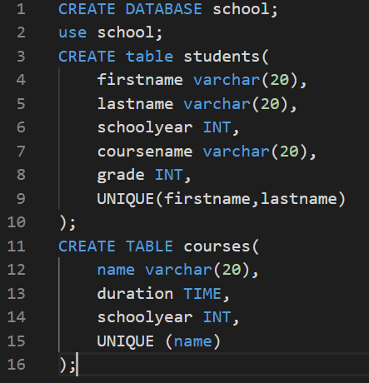

So, with this schema a student isn’t allowed to be enrolled in several courses but a courses can have no enrolled student.

**2 Alternate Solution**

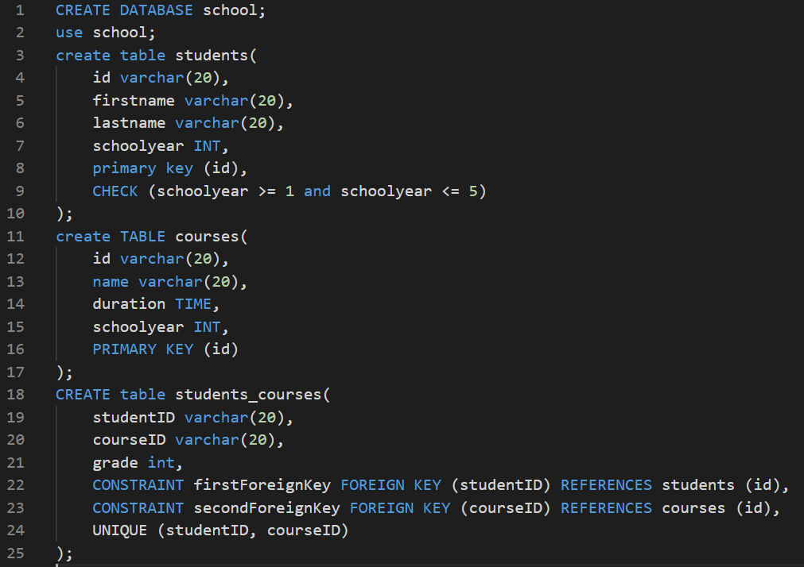

**3 Comparing the two models**

Disk space usage: The first database is using 32ko of space on the disk while the second is using 48ko.

The request to find all the courses is far shorter on the first database but it’s because every student can only have one course.

First database:



Second database:

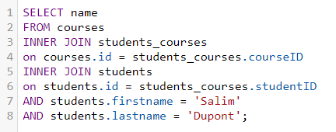

**4 Creating and populating the database**

Database without any primary key or foreign key:

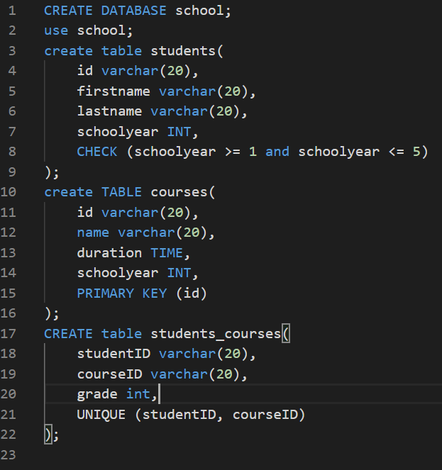

We can still modify every part of the database. The primary key and foreign key are indented to make life easier to programmer by avoiding mess in the database. Without these we can’t have more than one person with the same name, or the database would be a mess.

**5 database Script**